# **DAY 3**

## **Q.No. 1**: How to compare two JSON have the same properties without order?

let obj1 = {name:"Person1",age:5};

let obj2 = {age:5,name:"Person1"};

**Ans :**

The object doesn’t have index, the below code will compare the two JSON irrespective of the order and provide the output as True if they are equal, else false.

**Code :**

let obj1 = {name:"Person1",age:5};

let obj2 = {age:5,name:"Person1"};

if(obj1=obj2){

console.log("True");

}

else{

console.log("False");

}

**Output Screen shot:**

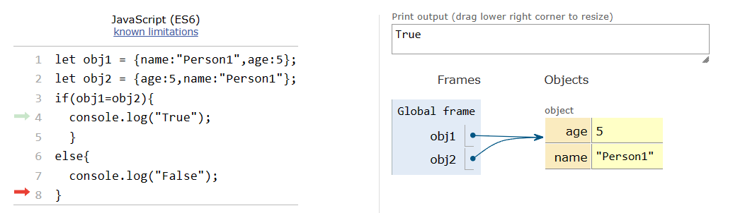

## **Q.No. 2:**